**Release Notes-**

Please download PyCharm Community Edition-

* Create a project name
* Go to settings on the right side the screen 🡪settings
* Go to Python Console 🡪python Interpreter 🡪 Save
* Paste the code in project.
* Right click on the project 🡪Mark Directory 🡪 on sources root
* Now click on 3 line icon(main menu)- Files🡪Invalidate Caches🡪 Invalidate and restart –>Which will restart your application
* Main Menu🡪View🡪Tool Bar🡪PythonPackages.

A search opens belong install – selenium and openpyxl

Note – Excel file should be named as ***contacts-messages*** only .And excel should be passed in PyCharm as shown below .

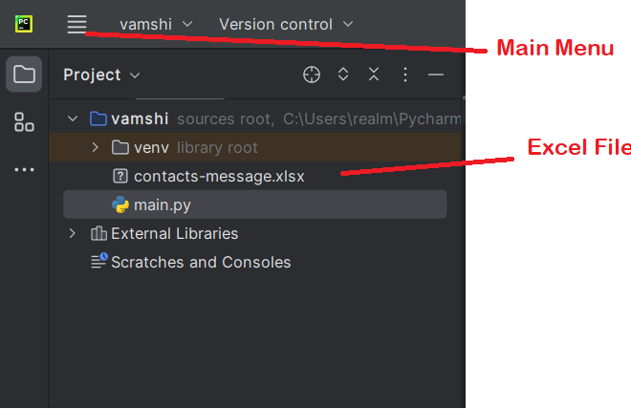

Excel Format

|  |  |
| --- | --- |
| Number | text |
| 81928839389 | Hi Priya bcviadvidv |